
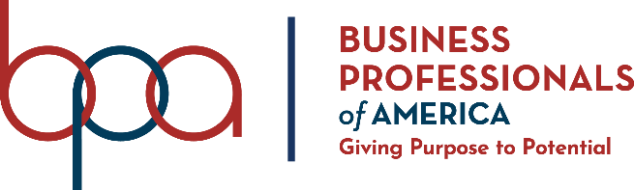
Human Resource Management
(535)

STATE – 2020

PRELIMINARY

Presentation Points (140 points)

Specification Points (20 points)

TOTAL POINTS (160 points)

Failure to adhere to any of the following rules will result in disqualification:
- Contestant must hand in this test booklet and all printouts. Failure to do so will result in disqualification.
- No equipment, supplies, or materials other than those specified for this event are allowed in the testing area. No previous BPA tests and/or sample tests or facsimile (handwritten, photocopied, or keyed) are allowed in the testing area.
- Electronic devices will be monitored according to ACT standards.

No more than ten (20) minutes preparation
No less than three (3) and no more than five (5) minutes oral presentation
No more than three (3) minutes judges’ questions

Property of Business Professionals of America.
May be reproduced only for use in the Business Professionals of America
Workplace Skills Assessment Program competition.

Description
Assess interpretation of personnel policies and knowledge of human resource management.

Regional Final Scenario
Amy Mendez is an advertising representative in the marketing department of Professional Business Associates. While driving to a meeting in the company vehicle, a man pulled out in front of her causing her to slam on the brakes. Amy became angry and raced to catch up with the car, honked, and used a hand gesture to convey her feelings. She continued to tailgate the driver for several blocks. At a stop, the man got out of his car, took a picture of the PBA logo on the side of the vehicle, and told Amy he would report her to Professional Business Associates. Amy offered the man some company promotional items (a coffee mug, duffle bag, and a t-shirt) if he would not file a report. The man accepted the gifts and then proceeded to file a report to Professional Business Associates about the incident.
As a Human Resources Manager, how would you handle this situation? Use your Human Resources Manual as a guide.

A contestant will be DISQUALIFIED for violations of the Copyright and Fair Use Guidelines.

Contestants who do not submit an entry that follows this topic will be disqualified.

Solution—Topics may be found in the Human Resources Manual
- See Unacceptable Activities – pages 12-14
  - #1
  - #2
  - #3
  - #6
- See Disciplinary Actions – page 14
- See Violence in the Workplace – page 15
  - #2
- See Gifts – page 16

